**Ex 1: Process can be Idle**

**Definitions:**

* Ni = Process i is neutral
* Ti = Process i is trying
* Ci = Process i is in the critical section
* Fi = Process i has priority to enter critical section
* i = { 1, 2}

**Construction:**

1. We started by using “Mutex2” model that came with Eshmun.

S8 was removed since we have a precondition NOT(C1 AND C2)

Remark: we later introduce another state with the same naming, but different purposes.

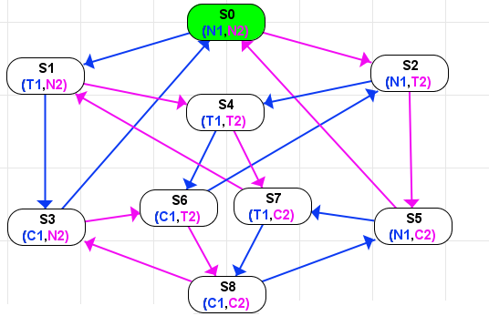

The end result was the following:

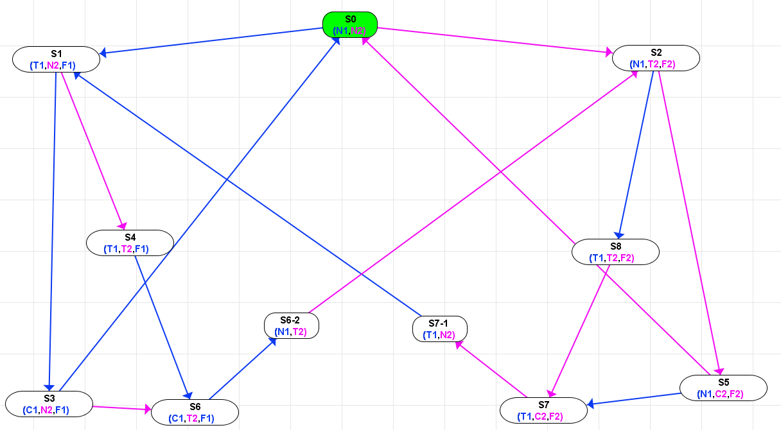

1. S4 was split into 2 states S4(T1,T2,F1) and S8(T1,T2,F2) in order to have fairness to decide who enters the critical section. F1 and F2 were used in several states for this purpose. Where if Fi is true, then Pi has priority to enter the critical section.
2. In order to achieve liveness we make sure the following scenarios are true.
   1. If P1 asks to be in the critical section and P2 doesn’t. Then P1 will enter the critical section (vice versa is true).

Example: S0 - > S1 -> S3

* 1. If both P1 and P2 ask to be in the critical section, then the one who asked first will enter, then the other.

Example if P1 asks first: S0 -> S1 -> S4 -> S6 -> S6-2 -> S2 -> S5

* 1. If P1 is in the critical section and P2 asks to enter the critical section. Then it will wait for P1 to finish, then it will enter. (vice versa is true )

1. In the figure below, we check liveness and we find it is true on every state. 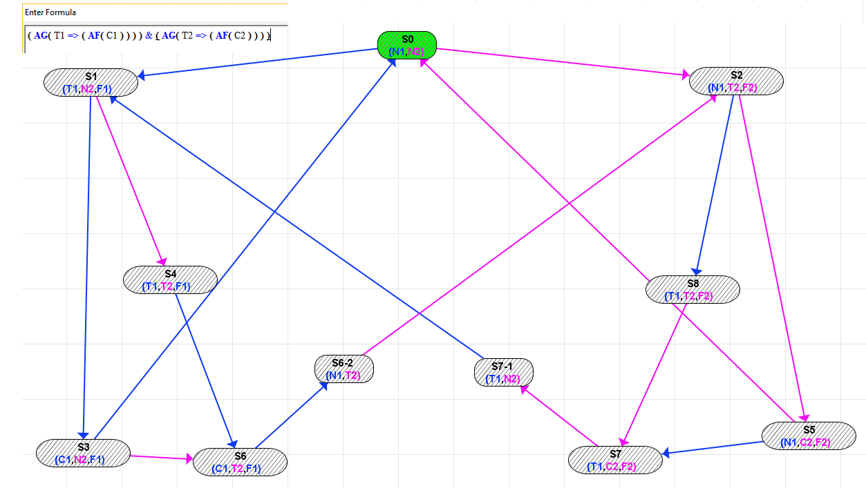
2. In the figure, we check if we can find a path where P1 can be idle, another one where P2 can be idle. We find it is true in the initial state.

EG(N2) is true since we have the path S0->S1->S3->S0 so it’s possible for P1 to keep working while P2 is idle

EG(N1) is true since we have the path S0->S2->S5->S0 so it’s possible for P2 to keep working while P1 is idle

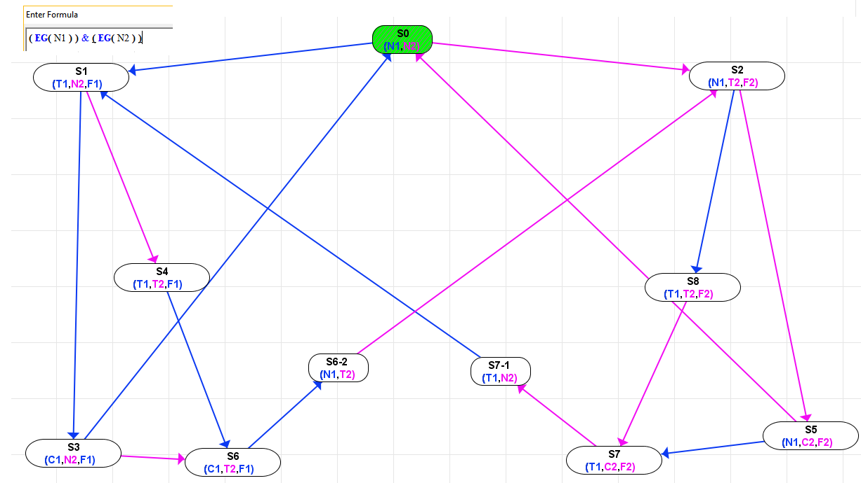

**Conclusion:**

So far we have solved liveness for 2 processes and it is possible to find a path where one of these processes are idle.